Lab Exercise - Azure Availability Set Using Azure Cloud Shell

Objective
In this lab, we will learn how to:
- Create an Azure Availability Set
- Deploy multiple Ubuntu Virtual Machines
- Place VMs inside the Availability Set
- Understand Fault Domains and Update Domains
- Install Apache Web Server
- Test High Availability
- Verify Availability Set configuration

What is an Availability Set?
An Availability Set is an Azure feature that improves VM availability by distributing VMs across:
- Fault Domains
- Update Domains
This protects applications from:
- Hardware failures
- Rack failures
- Planned maintenance

Architecture
Availability Set
| |
VM1 VM2
(Web Server) (Web Server)

Prerequisites
- Azure Subscription
- Azure Cloud Shell (Bash)
- Permission to create VMs

Lab Environment
Resource | Value
Resource Group | avset-lab-rg
Availability Set | myAvSet
VM1 | av-vm1
VM2 | av-vm2
OS | Ubuntu 20.04
VM Size | Standard_B1s
Disk Type | Standard_LRS

Step 1: Open Azure Cloud Shell
Open:
https://portal.azure.com
Launch Cloud Shell → Select Bash.

Step 2: Create Variables
RESOURCE_GROUP="avset-lab-rg"
LOCATION="eastus"
AVSET_NAME="myAvSet"
VM1="av-vm1"
VM2="av-vm2"
USERNAME="azureuser"

Step 3: Create Resource Group
az group create \
--name $RESOURCE_GROUP \
--location $LOCATION

Step 4: Create Availability Set
az vm availability-set create \
--resource-group $RESOURCE_GROUP \
--name $AVSET_NAME \
--platform-fault-domain-count 2 \
--platform-update-domain-count 2

Understanding the Parameters
Parameter | Purpose
platform-fault-domain-count | Separates VMs across physical hardware
platform-update-domain-count | Separates VMs during maintenance updates

Step 5: Create VM1 in Availability Set
az vm create \
--resource-group $RESOURCE_GROUP \
--name $VM1 \
--availability-set $AVSET_NAME \
--image Canonical:0001-com-ubuntu-server-focal:20_04-lts-gen2:latest \
--size Standard_B1s \
--storage-sku Standard_LRS \
--admin-username $USERNAME \
--generate-ssh-keys

Step 6: Create VM2 in Availability Set
az vm create \
--resource-group $RESOURCE_GROUP \
--name $VM2 \
--availability-set $AVSET_NAME \
--image Canonical:0001-com-ubuntu-server-focal:20_04-lts-gen2:latest \
--size Standard_B1s \
--storage-sku Standard_LRS \
--admin-username $USERNAME \
--generate-ssh-keys

Step 7: Open HTTP Port
VM1
az vm open-port \
--resource-group $RESOURCE_GROUP \
--name $VM1 \
--port 80 \
--priority 1010

VM2
az vm open-port \
--resource-group $RESOURCE_GROUP \
--name $VM2 \
--port 80 \
--priority 1020

Why Different Priorities?
Azure NSG rules cannot have:
- Same priority
- Same direction
Hence:
- VM1 → 1010
- VM2 → 1020

Step 8: Install Apache on VM1
az vm run-command invoke \
--resource-group $RESOURCE_GROUP \
--name $VM1 \
--command-id RunShellScript \
--scripts "
sudo apt update
sudo apt install -y apache2
echo '<h1>Welcome from VM1</h1>' | sudo tee /var/www/html/index.html
sudo systemctl restart apache2
"

Step 9: Install Apache on VM2
az vm run-command invoke \
--resource-group $RESOURCE_GROUP \
--name $VM2 \
--command-id RunShellScript \
--scripts "
sudo apt update
sudo apt install -y apache2
echo '<h1>Welcome from VM2</h1>' | sudo tee /var/www/html/index.html
sudo systemctl restart apache2
"

Step 10: Get Public IP Addresses
VM1 IP
az vm show \
-d \
-g $RESOURCE_GROUP \
-n $VM1 \
--query publicIps \
-o tsv

VM2 IP
az vm show \
-d \
-g $RESOURCE_GROUP \
-n $VM2 \
--query publicIps \
-o tsv

Step 11: Test in Browser
Open:
http://<VM1_PUBLIC_IP>
Expected Output:
Welcome from VM1
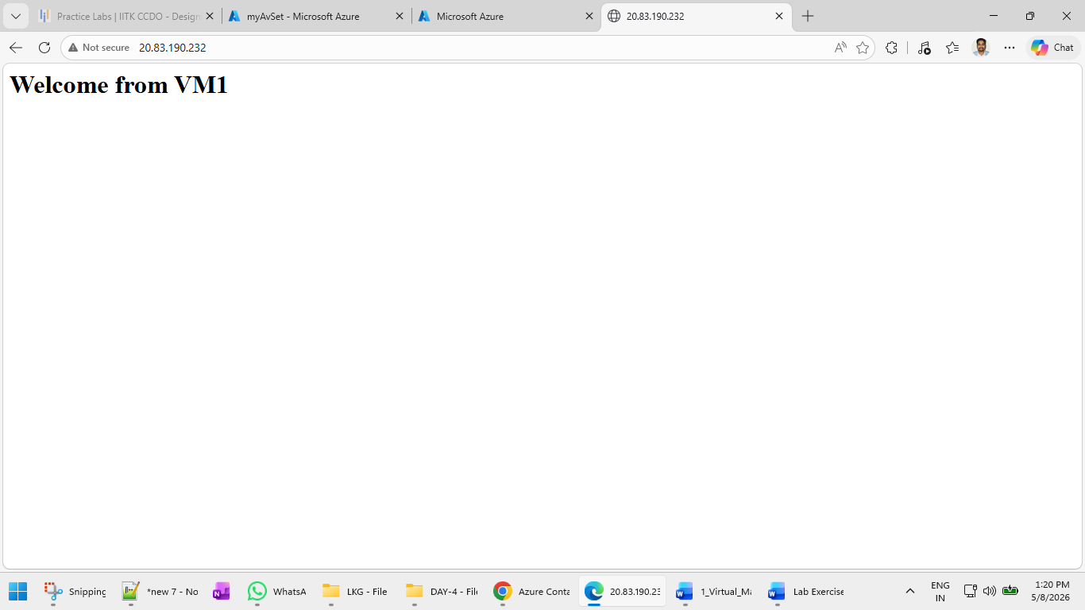

Open:
http://<VM2_PUBLIC_IP>
Expected Output:
Welcome from VM2

Step 12: Verify Availability Set
az vm availability-set show \
--resource-group $RESOURCE_GROUP \
--name $AVSET_NAME

Step 13: Check Fault Domains and Update Domains
az vm list \
--resource-group $RESOURCE_GROUP \
--query "[].{Name:name, FaultDomain:instanceView.platformFaultDomain, UpdateDomain:instanceView.platformUpdateDomain}" \
-d \
-o table

Sample Output
Name FaultDomain UpdateDomain
-------- ------------- ------------
av-vm1 0 0
av-vm2 1 1

Explanation
Component | Meaning
Fault Domain | Separate physical hardware
Update Domain | Separate maintenance reboot group
This ensures:
- Both VMs are not restarted together
- Both VMs are not placed on same rack/server

Testing High Availability
Stop VM1
az vm stop \
--resource-group $RESOURCE_GROUP \
--name $VM1

Verify VM2 Still Works
Open VM2 public IP again.
Application should still be available.
This demonstrates:
- Availability
- Fault tolerance

Step 14: Start VM1 Again
az vm start \
--resource-group $RESOURCE_GROUP \
--name $VM1

Learning Outcomes
After completing this lab, you learned:
- Azure Availability Set concepts
- Fault Domains
- Update Domains
- High Availability design
- VM deployment using Cloud Shell
- Apache installation automation
- Availability testing

Real Industry Use Cases
Industry | Example
Banking | Online transaction servers
Healthcare | Patient management systems
E-Commerce | Shopping applications
Telecom | Billing systems
Government | Citizen portals

Important Notes
Availability Sets:
- Protect against hardware failures
- Protect against planned maintenance
- Do NOT provide auto-scaling
For modern architectures, Azure recommends:
- Availability Zones
- Virtual Machine Scale Sets

Cleanup Resources
az group delete \
--name $RESOURCE_GROUP \
--yes \
--no-wait

